iPLUGE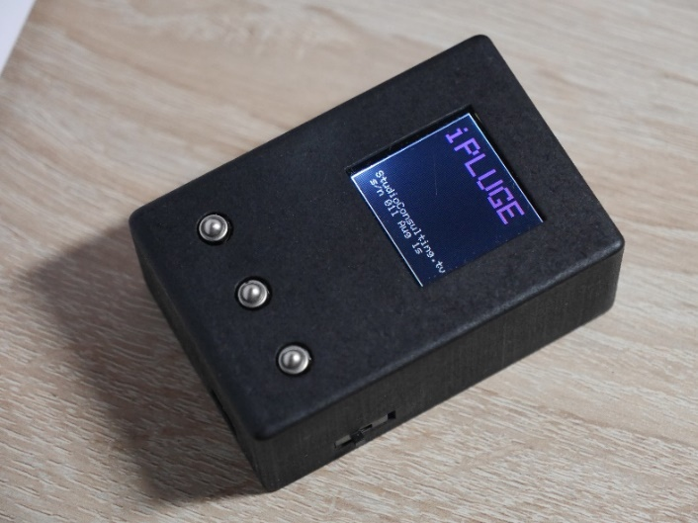
iPLUGE is a simple to use lightmeter utilising an RGBC photodiode array.
It has specific modes to measure Tungsten and LED sources for line-up charts and modes for OLED, LCD (RGBW and RGB LED and compact fluorescent backlights) and CRT measurement.
There are no user adjustments or calibration required for the meter.

Specifications:
Light sensor: TCS34725
1.4” 128 x 128 pixel Tft screen
Lux: 1 -65000
CT: Meter 2700-10000 (for 1-65,000 Lux). Monitors 6000-700K
Battery Li-Po 3.7V 400mAh. Approximately 5 hours continuous use.
Dimensions (HxWxD) 31mm x 52mm x 77mm
Contents
IPLUGE meter V4 software.
Carry case and USB A to micro B

TV Studio Consulting Ltd. 2022.
www.ipluge.co.uk

Charging the battery
The meter has a Li-Po battery charged through the micro USB B socket (5V) on the opposite end to the light sensor. When charging a yellow light appears on the base and this goes green when fully charged.
The power switch is on the right-hand side and the screen and the torch will illuminate when the unit is turned on. A red light will show on the base to indicate a low battery.

Lightmeter:
After the startup screen the meter will be in Tungsten/ LED source mode and gives readings in Lux for illumination and Kelvin for colour temperature.
The meter automatically adjusts for Tungsten or LED by the amount of infra-red in the light source. The small green digit bottom left of the screen will be less than 150 when a LED or fluorescent light source is detected.
The sensor is located on the front of the unit; however, the display can be rotated by pressing the middle button in for 1 second when in torch or meter mode. Each press will rotate the display through 90 degrees.
The light source should be +/- 10 degrees to the meter sensor for accurate readings.

The Meter Display
Meter Mode

Illumination in Lux

Colour temperature in Kelvin

Foot Candles

CIE x , y coordinates

RGB matching

The Left and Right buttons switch the meter to OLED, JOLED*, LCD-LED, LCD HDR, LCD-cfl, LCD-DBL*, and CRT modes.
Foot candles are also displayed for backwards compatibility with Pentax spotmeter as well as CIE x and y coordinates and Colour Temperature.
For the OLED, and CRT light sources the Lux is averaged over several readings to help reduce screen flicker effects.
*JOLED cover the new small oled screens, 22”,24” and 32” from LG, ASUS and many other manufacturers. LCD-DBL are for the new dual lcd screens like the Sony HX310 or Eizo CG3146

TORCH
There is a torch mode, because the sensor board has a white LED and it seems a shame not to allow it to be used.
RGB
The final display mode is a test function that displays the raw RGBC levels, and an RGB bar ranged around the higher of the level signals. It gives a rough indication of the light source spectrum.

MONITOR WHITE LEVEL
To measure the monitor peak white level and colour balance, display either Picture Line Up Generating Equipment, which is a test waveform for monitor calibration, test signals may also be incorporated into some colour bar signals or use the peak white bar.
Place the sensor directly touching the screen for correct measurement.
Don’t push hard as some LCD screens are quite flexible.
A glass protection screen will give an incorrect absolute reading.
For very large monitors with large pixels it is best to take readings in multiple places as the meter sensor is small compared to the monitor pixel size.

Levels for close monitoring of Broadcast monitors
This is very much a personal preference, but suggested starting points are:

For HD
Lux on peak white will generally be in the 95-120 range for vision control rooms with ambient light levels around 5-20 Lux.
Colour Temperature for Rec 709 should be 6500K

For HDR
Lux on peak white will generally be in the 500-1000 range for vision control rooms with ambient light levels around 50-200 Lux. It is important to note that many monitors cannot achieve the high lux level (for instance the Sony X300 limits at 300 lux) required to meet the specification, nor would you normally want to monitor at that level in a control room.
(Rec 2100: HD,4K or 8k at 10 or 12 bit depth, p frame rates only).
Line up the monitor in rec 709, eotf 2.4 to 100Lux and required CT, then switch to HDR mode.

Lining up a Monitor stack
It is important to establish the monitor types in a stack so a choice can be made as to which one will be the master reference. This is often the Transmission or main shaders monitor.
Once the types are established it is important to realise that there will always be some differences unless all the monitors are the same type by the same manufacturer and roughly the same age, and even then, the viewing angle can cause colour shifts.

Set the monitor to a peak white signal and adjust contrast to 100Lux
Adjust the red and blue gains to get the correct colour temperature.
Set the monitor to a 20% white field (or the third PLUGE BLOCK) where the Lux reading should be around 2.5 and adjust the Red and Blue Bias.
Repeat the process until the monitor is within 0.002 of the specified coordinates.

Using the CIE x & y co-ordinates on the meter will allow the white point to be set to the meter sensor but may still cause the monitors to appear badly matched. This is partly due to the different strengths of the RGB elements of the light sources in the monitors, especially when comparing with a CRT to the Dyes used in the meter sensor, and the sensitivity of your eyes RGB receptors.
Offsetting a OLED or LED monitor will help make them appear the same as the CRT.
CRT x,y co-ordinates for 6500k are 0.313,0.329
To match an OLED or LCD to a CRT use these coordinates: x,y 0.307,0.318

Reading Hold
Press the middle button in any of the monitor modes to freeze the readout for 15 seconds.

RGB Monitor Matching
The meter has been calibrated on specific monitors to 6500K and the RGB numbers at the bottom show how far away your monitor is from the original source monitor.
If you have multiple monitors of the same type you can ‘GRAB’ the RGB values and use them to compare your monitors.
By pressing LEFT & RIGHT buttons simultaneously you can access the grab screen.
Place the meter on your reference monitor peak white and press the middle button.
The meter will return to the previous display screen but now display ‘grabbed monitor’
Matching can be performed after setting lux levels first to match.
Matching does not work across different monitor types.
To return to ref values, select METER, then grab a new reference, or repower the meter.

4K OLED (Domestic)
These HDR screens use a white OLED cell as well as RGB ones, and when the white cell is on varies by manufacturer. iPLUGE cannot correctly measure CT when the white cell is on.

WARRANTY Thank you for your purchase of an iPLUGE.
The Warranty covers any defects in material or workmanship under normal use
during the Warranty Period of 1 year from date of purchase. TV Studio Consulting Ltd.,
will repair or replace, at no charge, the product or parts of the product that proves defective
because of improper material or workmanship, under normal use and maintenance.
What does this warranty not cover? This Warranty does not cover any problem that is caused by: conditions, malfunctions or damage not resulting from defects in material or workmanship.
What do you have to do? To obtain warranty service, you must first contact us obtain an RMA number via the website www.ipluge.co.uk/terms.html

